Input data :-

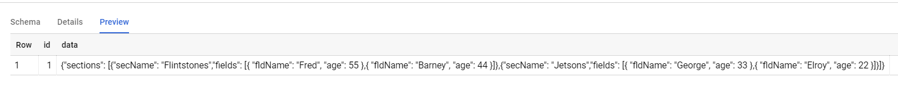

Coll ’id’: - data (1)

Coll ’data’: - data

In a data column in BigQuery, I have a JSON object with the structure:

{

"sections": [

{

"secName": "Flintstones",

"fields": [

{ "fldName": "Fred", "age": 55 },

{ "fldName": "Barney", "age": 44 }

]

},

{

"secName": "Jetsons",

"fields": [

{ "fldName": "George", "age": 33 },

{ "fldName": "Elroy", "age": 22 }

]

}

]}

Output :-

